Agricultural Decision Support System (DSS) using SSIS and Power BI

1. Dataset Description
This project is based on agricultural data collected from multiple heterogeneous sources. The data was distributed across three different file formats:
- Excel file (Dist1.xlsx)
- CSV file (Dist2.csv)
- Text file (Dist3.txt)
Dataset Attributes:
The dataset contains the following columns:
- Date: Represents the date of the agricultural record
- Location: Indicates the region/state in India
- Crop: Type of crop (e.g., Rice, Wheat, Tomato, etc.)
- Soil_Moisture: Soil moisture percentage
- Temperature_C: Temperature in Celsius
- Yield_kg_per_hectare: Crop yield per hectare
Data Challenges:
- Different data formats (Excel, CSV, TXT)
- Inconsistent date formats (7-digit and 8-digit values)
- Data type inconsistencies (Unicode vs non-Unicode)
- Possible invalid crop values across datasets

2. Transformations in SSDT (SSIS)
The project implements a complete ETL (Extract, Transform, Load) process using SSIS.
2.1 Extract Phase
Data was extracted from:
- Excel Source (Dist1)
- Flat File Source (Dist2 & Dist3)

2.2 Transform Phase
Several transformations were applied to clean and standardize the data:
🔹 Data Conversion
Used to convert all columns into a consistent data type (Unicode string) to avoid type mismatch errors.
🔹 Derived Column
Used to:
- Standardize date formats into a unified format
- Create new transformed columns
- Clean inconsistent values
🔹 Conditional Split
Applied to handle inconsistent date formats:
- Records were split into two groups:
  - 7-digit date format
  - 8-digit date format
🔹 Derived Column (Post-Split)
Each group was processed separately to correct the date format using string functions.
🔹 Union All
After transformation, all data streams were merged into a single unified dataset.
🔹 Lookup Transformation (Data Validation)
Used to validate crop values against a reference table (CropReference):
- Matching records → passed to main flow
- Non-matching records → redirected to error file (LookupNoMatch.txt)

2.3 Load Phase
🔹 OLE DB Destination
The cleaned and validated data was loaded into SQL Server table (CropData).
🔹 Execute SQL Task
Used to truncate the destination table before loading new data, implementing an Initial Load strategy.
🔹 Row Count
Used to count the number of processed rows for monitoring purposes.
🔹 Sort
Applied before loading to ensure structured and organized data.

2.4 Error Handling
Invalid records (non-matching crops) were:
- Redirected using Lookup No Match Output
- Stored in a separate file for further analysis
This improves data quality and ensures reliability.

3. Transformations in Power Query (Power BI)
After loading data into SQL Server, Power BI was used for further transformation and visualization.
Applied Transformations:
- Adjusted data types for all columns
- Renamed columns for better readability
- Ensured consistent date formatting
- Removed unnecessary or null values (if any)
- Prepared calculated measures (e.g., average yield)

4. Components Used in Workflow
The following SSIS components were used:
Component |  | Purpose
Excel Source |  | Extract data from Excel file
Flat File Source |  | Extract data from CSV and TXT
Data Conversion |  | Standardize data types
Derived Column |  | Create and modify columns
Conditional Split |  | Separate data based on conditions
Lookup |  | Validate and map data
Union All |  | Merge multiple data streams
Row Count |  | Count processed records
OLE DB Destination |  | Load data into SQL Server

5. Data Visualization and Analysis (Power BI)
The Power BI dashboard includes multiple visualizations:

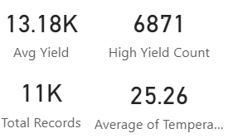
1. KPI Cards
- Average Yield (~13.18K)
- Total Records (11K)
- High Yield Count (6871)
- Average Temperature (~25.26°C)
Insight:
The dataset shows a relatively high average yield, indicating efficient agricultural performance across regions.
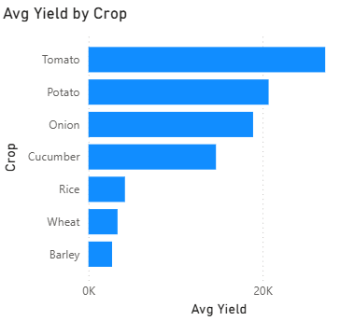
2. Bar Chart – Average Yield by Crop
-Shows yield comparison across crops
Insight:
- Tomato has the highest yield
- Wheat and Barley have the lowest
- Indicates crop productivity differences
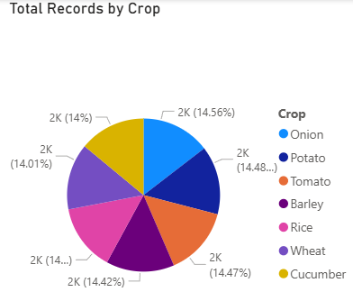
3. Pie Chart – Total Records by Crop
- Shows distribution of crops
Insight:
- Data is relatively balanced across crops
- No extreme bias toward a single crop
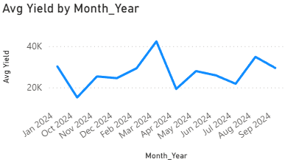
4. Line Chart – Average Yield by Month-Year
- Shows trend over time.
Insight:
- Yield fluctuates over months
- Indicates seasonal impact on production

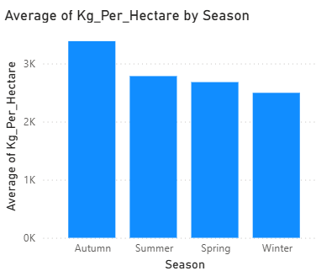
5. Column Chart – Yield by Season
- Shows seasonal performance
Insight:
- Yield is relatively stable across seasons
- Slight variation suggests climate influence
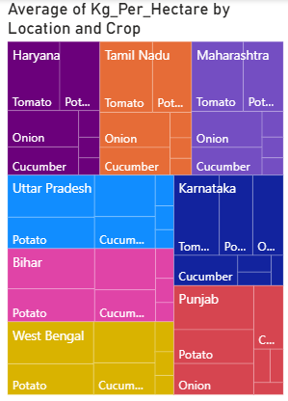
6. Tree Map – Yield by Location and Crop
- Shows hierarchical distribution
Insight:
- Some states like Maharashtra and Tamil Nadu dominate
- Crop performance varies by region

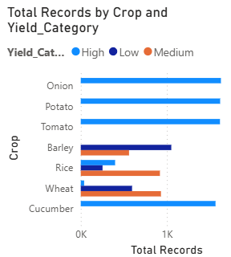
7. Bar Chart – Records by Crop and Yield Category
- Shows classification (High / Medium / Low)
Insight:
- Majority of crops fall into high yield category
- Indicates overall good agricultural efficiency

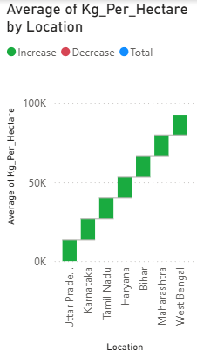
8. Waterfall Chart – Yield by Location
- Shows cumulative contribution
Insight:
- Each region contributes incrementally to total yield
- Help identify high-performing locations

